2016_01_26 MM1574 (Glycine Synthase) Knockout

## Design/Order Primers (01/25)

Designed 2 sets of primers with NotI sites on the outsides and AscI sites on the insides. The plan is to amplify both sets, then cut them both with AscI and ligate them together. Then we’ll cut with NotI and ligate them with cut plasmid. Primer sequences are as follows:

KOMmp1574upfwdNot (MR1)

5’ – AAG CGG CCG CAG GTC GTT TGA AAT TTC ATC G – 3’

KOMMP1574uprevAsc (MR2)

5’ – AAG GCG CGC CCA TAA AGA CAC CTA ATA AAC AAT C – 3’

KOMMP1574dnfwdAsc (MR3)

5’ – AAG GCG CGC CAT GAT TTA AAC GCT ATT TGT AAC G – 3’

KOMMP1574dnrevNot (MR4)

5’ – AAG CGG CCG CTT GAT AAT AAT TAT ATA TAC CC – 3’

## PCR Amplification (01/26)

Received primers and diluted them with TRIS-E (TRIS+EDTA to scavenge magnesium and keep DNA from reacting) to 200 uM stocks, then diluted those to get 20 uM stocks of each primer. Measured genomic DNA at 5136 ng/uL, diluted it to 30 ng/uL as follows:

2 uL DNA + 48 uL sterile water 🡪 205.44 ng/uL (dilution 1)

7.3 uL DNA + 42.7 uL sterile water 🡪 30 ng/uL (dilution 2)

Created PCR reaction mixes as follows:

|  |  |  |
| --- | --- | --- |
| Reagent | Rxn 1 Volume (μL) | Rxn 2 Volume (μL) |
| Water | 71.0 | 71.0 |
| 5X iProof HF Buffer | 20.0 | 20.0 |
| 10mM dNTPs | 2.0 | 2.0 |
| MR1 | 2.0 | 0 |
| MR2 | 2.0 | 0 |
| MR3 | 0 | 2.0 |
| MR4 | 0 | 2.0 |
| Template | 2.0 | 2.0 |
| iProof polymerase | 1.0 | 1.0 |
| Total Volume: | 100.0 | 100.0 |

From each reaction type, created two 30 uL PCR reactions (tubes 1 and 2 are Rxn. 1; tubes 3 and 4 are Rxn. 3). Reaction program was as follows:

Cycle Temperature Time # Cycles

initial denaturation 98ºC 2’ 1

denaturation 98ºC 15”

annealing **53ºC** 15” 30

extension 72ºC 30”

final extension 72ºC 1’ 1

## More PCR and Restriction Digest (01/27)

My first PCR was done with very little overall volume (60 uL per reaction). Tom wants more, so I redid it with 300 uL per reaction, 3 tubes each. Thus, I made a reaction mix with 4 reactions worth for each as follows:

|  |  |  |
| --- | --- | --- |
| Reagent | Rxn 1 Volume (μL) | Rxn 2 Volume (μL) |
| Water | 284.0 | 284.0 |
| 5X iProof HF Buffer | 80.0 | 80.0 |
| 10mM dNTPs | 8.0 | 8.0 |
| MR1 | 8.0 | 0 |
| MR2 | 8.0 | 0 |
| MR3 | 0 | 8.0 |
| MR4 | 0 | 8.0 |
| Template | 8.0 | 8.0 |
| iProof polymerase | 4.0 | 4.0 |
| Total Volume: | 400.0 | 400.0 |

Then ran PCR with very slight change in program (on lengthening time):

Cycle Temperature Time # Cycles

initial denaturation 98ºC 2’ 1

denaturation 98ºC 15”

annealing **53ºC** 15” 30

extension 72ºC 20”

final extension 72ºC 1’ 1

Using PCR products, did digest with AscI, but accidentally used 3:1 buffer at first. Tried to balance with CutSmart, so final amounts of each component are as follows:

DNA Species

Reagent Rxn 1 Rxn 2

water 18.0 18.0

10X Buffer 3.1 2.0 2.0

10X Cutsmart Buffer 4.0 4.0

DNA prep 1 12.0 0.0

DNA prep 2 0.0 12.0

*Asc*I 4.0 4.0_____

Total volume 40.0μL 40.0μL

Meanwhile, ran a 2nd gel to see if both upstream and downstream were amplified; gel showed 2 bands at 1 kb, which suggests I got both products I wanted.

## Gel Purification, Ligation, and PCR #2

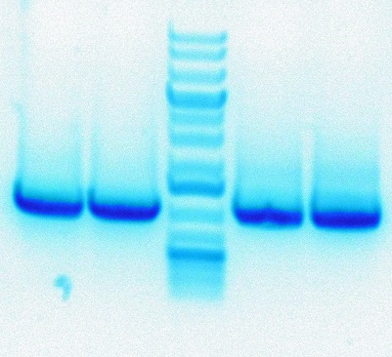Using the digests from yesterday, I ran all 40 uL of each digest on a gel to purify. Rxn 1 is pictured on the left, Rxn 2 is pictured on the right, and a ladder is in the middle (each reaction has 2 lanes). Gel picture:

After imaging, I cutout each reaction and weighed the out; Rxn 1 weighed 0.27 g, Rxn 2 weighed 0.355 g. I ran gel purification on these cutouts, using 12 uL of EB buffer in each case so that I ended up with 2 concentrated pools of digested DNA.

Following purification, I created a ligation reaction to link together the two AscI sites as follows (note that I diluted each digested DNA sample at 1:10):

__________________________

Reagent Volume_

water 1.0

10X FastLink Buffer 1.5

10 mM ATP 1.5

Digested Rxn 1* 5.0

Digested Rxn 2* 5.0

Fast Link Ligase 1.0_

Total volume 15.0μL

I spun down this reaction at 4500 RPM to gather everything, then let it incubate at RT for 20 min. I heat inactivated at 75°C for 15 min, then transferred to RT on the bench for 15 min. After a pulse spin at 4500 RPM to gather everything again, I diluted to 1:5 and 1:10 mixtures of the ligation.

The next step was 2nd PCR, using *NotI* to cut the outer ends. For this purpose, primers MR1 and MR4 were used. For each reaction, I setup 3x100 uL tubes, so master mixes were as follows:

|  |  |  |
| --- | --- | --- |
| Reagent | 1:5 Volume (μL) | 1:10 Volume (μL) |
| Water | 284.0 | 284.0 |
| 5X iProof HF Buffer | 80.0 | 80.0 |
| 10mM dNTPs | 8.0 | 8.0 |
| MR1 | 8.0 | 8.0 |
| MR4 | 8.0 | 8.0 |
| Template | 8.0* | 8.0** |
| iProof polymerase | 4.0 | 4.0 |
| Total Volume: | 400.0 | 400.0 |
|  |  |  |

Cycle Temperature Time # Cycles

initial denaturation 98ºC 2’ 1

denaturation 98ºC 15”

annealing **53ºC** 15” 30

extension 72ºC 30”

final extension 72ºC 1’ 1

I left these reactions in the thermocycler and depended on Tom to take care of them. Next steps will be verifying that I got the correct product, then digesting it and the vector with *NotI* and ligating them together. I believe this could all be done within one day, either tomorrow (1/29) or Monday (2/1).

## RE Digest #2, Ligation #2, Transformation into E. coli (02/01)

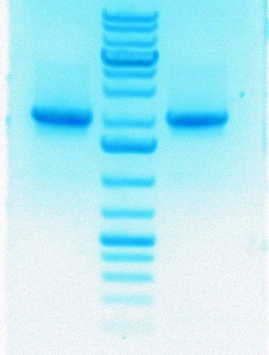I have 6 reactions from PCR last Thursday, 3 of 1:5 ratio and 3 of 1:10 ratio. First step is to PCR purify both sets, which I did while reserving 10 uL of each for a gel. Gel image showed 1 band for each (Tom says they’re at 2 kb, so it looks good). Gel image follows:

With the 12 uL elutions of each and the pcruptNeoR plasmid, I setup more RE digestions with NotI-HF; table is as follows:

|  |  |  |  |
| --- | --- | --- | --- |
| Reagent | Plasmid Volumes | 1:5 Volumes | 1:10 Volumes |
| Water | 8 | 4 | 4 |
| CutSmart Buffer | 4 | 2 | 2 |
| DNA Prep | 24 | 12 | 12 |
| NotI-HF | 4 | 2 | 2 |
| Total | 40 | 20 | 20 |

As per RE digest procedure, I allowed the reactions to proceed at 37°C for 1 hour, then inactivated the enzymes for 20 min at 80°C.

Following the digest, I gel purified including the MinElute steps, ending with 12 uL each of 1:5, 1:10, and vector. Next was the ligation, where Tom stated that I wanted 50 fmol of vector and 8x that (400 fmol) of insert. I measured my DNA samples and got the following numbers:

Vector DNA: 109.3 ng/uL

1:5 DNA: 153.9 ng/uL

1:10 DNA: 130.4 ng/uL

Calculations of the DNA amounts in fmol were as follows:

Based on this, I performed ligations using only the 1:5 insert DNA dilution as follows:

|  |  |
| --- | --- |
| Reagent | Volume |
| Water | 5.0 |
| 10X FastLink Buffer | 1.5 |
| 10 mM ATP | 1.5 |
| Digested 1:5 DNA Prep | 4.5 |
| Digested pcruptNeoR | 1.5 |
| FastLink Ligase | 1.0 |
| Total | 15.0 μL |

After incubating these at room temperature, inactivating at 75°C, and bringing back to room temperature, I transformed two tubes of 70 uL *E. coli* cells (one plastic for Tom, one glass for Eli) with 2 uL of ligation mixture each.

After allowing for 1 hour of outgrowth in SOC media for each, during which I poured plates with LB + Kan. I plated my cells on the plates at 2.5, 10, and 50 uL volumes from each of the 2 tubes for 6 plates total and brought total plated volume to 100 uL with SOC medium. I left them overnight to grow.

## Screening and Pouring Anaerobic Plates (2/02)

Cells in all plates grew a whole bunch. I selected 15 colonies from the “plastic” plate with 2.5 uL and dissolved each in 100 uL of LB (Kan). Then I made a master mix for PCR screening. Mix as follows:

|  |  |  |  |
| --- | --- | --- | --- |
| Reagent | Volume (1 Tube) | Volume (16X) |  |
| Water | 34.5 | 552.0 |  |
| 5X iProof Buffer | 10.0 | 160.0 |  |
| 10 mM dNTPs | 1.0 | 16.0 |  |
| Candidate in LB | 2.0 | - |  |
| Forward Primer (MR1) | 1.0 | 16.0 |  |
| Reverse Primer (MR4) | 1.0 | 16.0 |  |
| FastLink Ligase | 0.5 | 8.0 |  |
| Total | 50.0 μL | 768.0 μL | 0.0 μL |

Ran PCR with slightly longer extension time:

Cycle Temperature Time # Cycles

initial denaturation 98ºC 2’ 1

denaturation 98ºC 15”

annealing **53ºC** 15” 30

extension 72ºC 40”

final extension 72ºC 1’ 1

In the meantime, I mixed up and autoclaved media for pouring anaerobic plates. Following my screening PCR, I loaded all 15 samples into a gel and ran it…gel is below

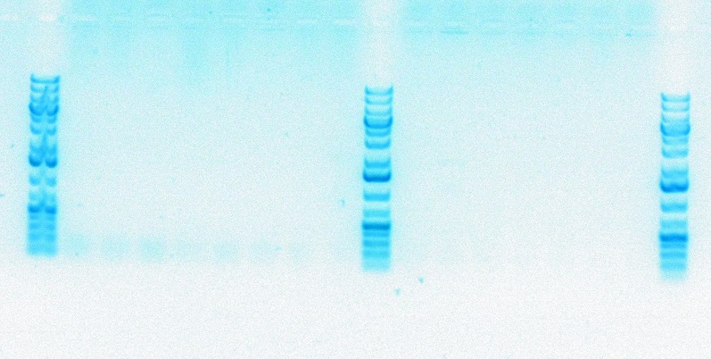

Got nothing, will re-do using boil preps and a vector control.